DEPARTMENT OF PUBLIC WORKS GROUND TRANSPORTATION BUREAU
CITY OF NEW ORLEANS

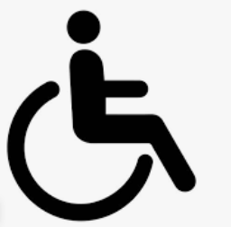
Latoya Cantrell Sarah McLaughlin Porteous
Mayor Acting Director

Accessible Taxicab (AT) Specifications

In accordance with New Orleans City Code 162-202, the following vehicle models were approved after a review by the Mayor’s Advisory Council (MAC) for Citizens with Disabilities.

- Five (5) model year old or newer side-entry accessible minivan.
  - Rear-entry vehicles are not permitted.
  - Vehicle age requirements must meet CCNO 162-613 (cannot be older than 15 years)
  - If vehicle is 9 model years or older, an ASE inspection form is required.
- A copy of the certified engineering test reports to show vehicle manufacturer or vehicle.
modifier’s compliance with the Federal Motor Vehicle Safety Standards (FMVSS) crash test certifications is required to be submitted prior to vehicle approval.
- Applicants seeking to use an alternative vehicle must contact the MAC for review and approval.

All AT CPNC vehicles are required to have one distinct color and logo:
- Vehicle Color – Taxicab line color
- “Handicapped” decals must be placed on the vehicle per the standards of the Department of Public Works
- All required decals and lettering as required for standard taxicabs.

AT CPNC vehicles require minimum insurance coverage:
- For injury to one person in any one accident: $25,000.00
- For injury to two or more persons in any one accident: $50,000.00
- For property damage in any one accident: $25,000.00

For additional questions or information, please contact the Ground Transportation Bureau at 504- 658-7170 or online at https://www.nola.gov/gtb.

Revised July 12, 2023

1300 PERDIDO STREET | ROOM 6E03 | NEW ORLEANS, LOUISIANA 70112 TELEPHONE: 504.658.7170

