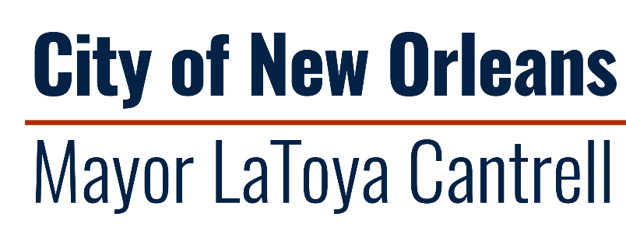

Notice of Funding Availability
For Moving Assistance of Rehoused Persons

Application Packet

Timeline
Released: December 6, 2023
Virtual Information Session: December 18, 2023
Application Deadline: January 3, 2023
Selection of Subrecipients Announced: January 2023

Mayor's Office of Homeless Services and Strategies
1340 Perdido St, Suite 962
New Orleans, Louisiana 70112
(504) 658-2598 | https://nola.gov/health-department
As of SAVEDATE \@ "d-MMM-yy" \* MERGEFORMAT 29-Sep-23
Application Packet
Applicant Organization:
Applicant Address:
Form of Business: Nonprofit For-Profit Other:_______________
Zip Code(s) where your project serves:

Program Summary: Provide a summary of the program or project: (250 words maximum)
Total Amount of Funding Requested:
Proposed Number of Participants Reached:
Length of Proposed Program or Project:
Proposed Program or Project Start Date:
Proposed Program or Project End Date:

SECTION 1: PROGRAM OR PROJECT NARRATIVE
Please respond to the prompts below regarding your agency’s experience working with people experiencing unsheltered homelessness and your agency’s plan for implementing a rapid rehousing program. Please use Times New Roman, 12-point font with double spacing to facilitate reading by scorers. This packet, including both this section and Section 2 should not exceed 20 pages total.

SECTION 1A: ORGANIZATIONAL EXPERIENCE
Address each of the following questions below for the organization to demonstrate capacity and ability to execute successful programs/projects.
- Detail your organization’s experience in providing street outreach, housing navigation, housing placement, and effective case management. Please include any instances in which your organization has implemented a housing-first approach to service provision. Special consideration will be given to organizations with a track record of serving chronically homeless individuals.
- Outline your organization’s experience in providing programs that support successful, long-term housing placements that provide opportunities for education and positive change.

SECTION 1B: EVALUATION PLAN
- Describe the method(s) of evaluating the success of the proposed project. Define the metrics that will be used to evaluate the program impact described in the project narrative. Include outcomes that aligned with the strategic aim of this NOFA.

SECTION 1C: CAPACITY AND TIMELINE
- Detail the program or services that your organization will deliver using the funds available through this NOFA, including whether that program is an existing program that will be expanded or a new program that will be implemented.
- Describe your organization’s current or new staff positions that will oversee and implement the program functions. Please include resumes of staff who will be integral to the program if they are existing staff in a separate attachment, if applicable.
- Include a timeline for the project development and implementation, including key milestones.

SECTION 2: PROGRAM OR PROJECT BUDGET
Please describe your proposed budget by responding to the prompts below. When replying to prompts, please use Times New Roman, 12-point font with double spacing to facilitate reading by scorers. When submitting your proposal, include separate attachments with your excel document budget narrative and your organization’s financials, including your most recent 990 and a copy of your most recent financial statement. If you have an audited financial statement, please submit it as a separate attachment.

SECTION 2A: BUDGET AND BUDGET NARRATIVE
Please provide a description of project costs below in a narrative format. Please also include an Excel document that breaks down costs across allowable categories. All such costs should be limited to the amounts that are necessary and reasonable to accomplish the program activities and must meet applicable federal eligibility restrictions. Any awarded project will be subject to OHSS’ feasibility and cost reasonableness analyses.

Allowable costs include, but are not limited to:
- Program staff salaries, including fringe and benefits
- Organizational administrative/overhead costs;
- Office supplies, outreach & promotional materials;
- Travel & transportation costs;
- Resources to support immediate program participants needs

Restrictions on use of funds include, but are not limited to:
  - Organizations must operate within the geographic boundary of the City of New Orleans
  - Program recipients or project participants must be City of New Orleans residents.
  - Administrative costs must not exceed 10% of the total requested budget.
  - Proposed budget should not include the use of funds to purchase food for meetings or events.

Submit your most recent 990 and a copy of your most recent financial statement. If you have an audited financial statement, please submit.

Acknowledgements
The undersigned certifies and makes assurance of the Applicant’s compliance with:
- Organization does not owe Federal debt, any State of Louisiana debt, or any City of New Orleans debt.
- Applicant organization has met audit requirements to be considered for funding, including submission of organization’s most recent completed audit, and all audits of previously funded organizations are clear of ineligible/disallowed costs related to all funding provided by the City of New Orleans.
- No contractor principal, member, or officer has, within the preceding five years, been convicted of, or pled guilty to, a felony under state or federal statutes for embezzlement, theft of public funds, bribery, or falsification or destruction of public records.
- Proposals are in compliance with City funding commitments and do not have unresolved compliance issues.
- Title VI of the federal Civil Rights Act of 1964 https://www.hhs.gov/civil-rights/for-individuals/special-topics/needy-families/civil-rights-requirements/index.html;
- Title IX of the federal Education Amendments Act of 1972 https://www.justice.gov/crt/title-ix-education-amendments-1972
- The Equal Employment Opportunity Act and the regulations issued thereunder by the federal government https://www.eeoc.gov/statutes/laws-enforced-eeoc
- The Americans with Disabilities Act of 1990 and the regulations issued thereunder by the federal government http://www.ada.gov/pubs/ada.html;
- All contract employees performing services and/or work as a result of this solicitation must have documented legal authority to work in the United States of America;
- The condition that the submitted Application was independently arrived at, without collusion, under penalty of perjury; and
- The condition that no amount shall be paid directly or indirectly to an employee or official of the City of New Orleans as wages, compensation, or gifts in exchange for acting as an officer, agent, employee, subcontractor, or consultant to the Applicant in connection with the Procurement under this NOFA.
Yes No

_______________________________________________ _______________________
ORGANIZATION FED EMPLOYER ID NO.
_______________________________________________ ______________________
APPLICANT SIGNATURE DATE
_______________________________________________
PRINTED NAME
_______________________________________________
TITLE
PERSON RESPONSIBLE FOR PREPARATION OF APPLICATION
____________________________________  NAME | __________________________________  TITLE
________________________________________________________________________
ADDRESS
___________________________________ ____________ _______________________
CITY STATE ZIPCODE
____________________________________  PHONE NUMBER | __________________________________  EMAIL ADDRESS
PERSON RESPONSIBLE FOR PROGRAM AND CONTRACT MANAGEMENT
____________________________________  NAME | __________________________________  TITLE
________________________________________________________________________
ADDRESS
___________________________________ ____________ _______________________
CITY STATE ZIPCODE
____________________________________  PHONE NUMBER | __________________________________  EMAIL ADDRESS

