CITY PLANNING COMMISSION PUBLIC HEARING NOTICE
TUESDAY, APRIL 9, 2019
PUBLIC HEARING: 1:30 P.M.

CITY COUNCIL CHAMBER
(CITY HALL - 1E07)

THE CITY PLANNING COMMISSION IN ACCORDANCE WITH PROVISIONS OF ARTICLE 4 OF THE COMPREHENSIVE ZONING ORDINANCE 4,264 M.C.S., AS AMENDED, WILL HOLD A PUBLIC HEARING ON april 9, 2019 IN THE CITY COUNCIL CHAMBER (CITY HALL - 1E07) ON THE FOLLOWING PROPOSED AMENDMENTS TO THE COMPREHENSIVE ZONING LAW OF THE CITY OF NEW ORLEANS.

ZONING DOCKET 037/19 – Request by City Council Motion No. M-19-59 for a zoning change from an HU-RD2 Historic Urban Two-Family Residential District to an HU-RM2 Historic Urban Multi-Family Residential District, on Square 646, portion of an undesignated lot (elsewhere identified as Lots 6, 7, and 13 or Lots 5, 6, and 7), in the Third Municipal District, bounded by North Robertson Street, Franklin Avenue, Painters Street, North Claiborne Avenue, and Arts Street. The approximate area to be rezoned is designated as “Phase II” on the image included herein. The municipal addresses are 2515 North Robertson Street, 1525 Arts Street, and 2518 North Claiborne Avenue. (PD 7)

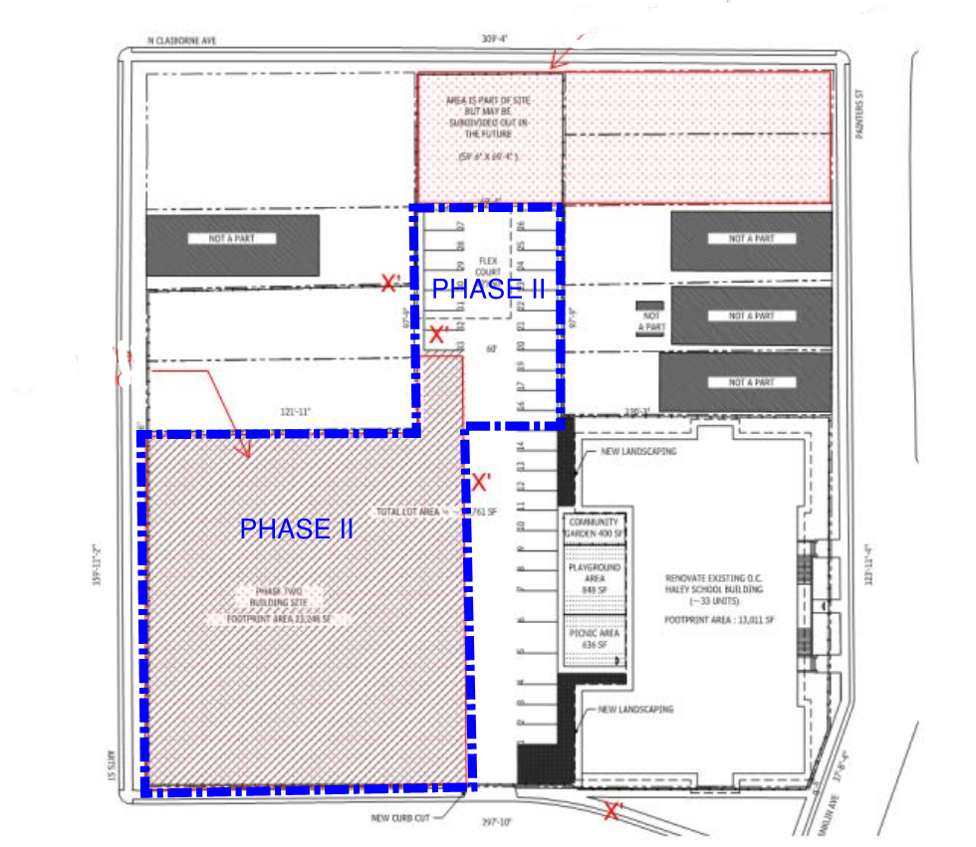
ZONING DOCKET 038/19 – Request by Greater Morning Star Church of Algiers for a conditional use to permit a neighborhood commercial establishment in an HU-RD2 Historic Urban Two-Family Residential District, on Square 211, Lot 14, in the Fifth Municipal District, bounded by Vallette Street, Lamarque Street, De Armas Street, Belleville Street, and Belleville Court. The municipal address is 1236 Vallette Street. (PD 12)

ZONING DOCKET 039/19 – Request by 1701 Eagle St, LLC for a conditional use to permit an established multi-family dwelling in an HU-RD2 Historic Urban Two-Family Residential District, on Square 231, Lot 35 or part of Lot 1, in the Seventh Municipal District, bounded by Eagle Street, Green Street, Hickory Street, and Monroe Street. The municipal addresses are 1701-1703 Eagle Street. (PD 3)

ZONING DOCKET 040/19 – Request by 822 Baronne, LLC for a conditional use to permit a hotel in a CBD-5 Urban Core Neighborhood Lower Intensity Mixed-Use District, on Square 235, Lot 20, in the First Municipal District, bounded by Baronne Street, Saint Joseph Street, Carondelet Street, and Julia Street. The municipal addresses are 822-822 ½ Baronne Street. (PD 1A)

THE CITY PLANNING COMMISSION, IN ACCORDANCE WITH ARTICLE 4 OF THE COMPREHENSIVE ZONING ORDINANCE 4,264 MCS AS AMENDED, WILL HEAR PROPONENTS AND OPPONENTS TO THE ABOVE PROPOSED CHANGES TO THE COMPREHENSIVE ZONING LAW OF THE CITY OF NEW ORLEANS. ALL INTERESTED PARTIES ARE ENCOURAGED TO ATTEND AND ALL RELEVANT COMMENTS CONCERNING THE PROPOSED CHANGES ARE ENCOURAGED. THE CPC HAS ESTABLISHED PUBLIC HEARING RULES WITHIN ITS ADMINISTRATIVE RULES, POLICIES, & PROCEDURES, WHICH ARE AVAILABLE ON THE CPC WEBSITE: WWW.NOLA.GOV/CPC. YOU MAY ALSO SUBMIT WRITTEN COMMENTS TO THE EXECUTIVE DIRECTOR IN ADVANCE BY MAIL (1300 PERDIDO STREET, 7TH FLOOR, NEW ORLEANS, LA 70112) OR EMAIL CPCINFO@NOLA.GOV. ALL WRITTEN COMMENTS MUST BE RECEIVED BY CLOSE OF BUSINESS ON THE MONDAY, EIGHT DAYS PRIOR TO THE HEARING DATE.
March 20, March 27, and April 3, 2019
Robert Rivers, Executive Director

RDR/skk

