**Morrison Road Improvements**

**(Mayo Boulevard-Bullard Avenue)**

The Morrison Road (Mayo-Bullard) project is a $23.6M street improvement project. Funding for this project is split between the Federal Highway Administration (80%) and the City of New Orleans bond program (20%). The scope of work varies by block and includes bridge reconstruction, pavement repairs, streetscape improvements such as ADA-compliant curb ramps, sidewalk repairs, additional greenspace, and bike lanes. This project also includes the reduction of one travel lane in the Eastbound direction only to facilitate multimodal accommodations and reduce speeding. 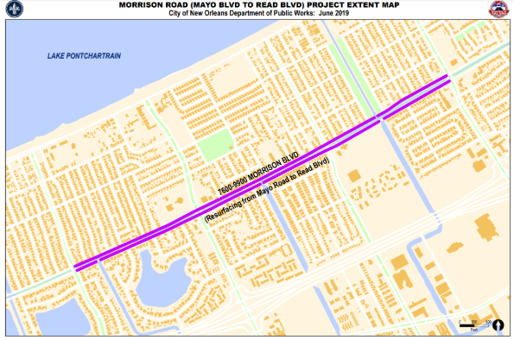

The scope of work for this project includes:

* Pavement repairs
* Repairs to three bridges on the eastbound side
* Replacements of two bridges on the eastbound side
* Installation of Americans with Disabilities Act-compliant curb ramps
* Two-way curb-protected bike lanes along the eastbound side of the Morrison Canal
* Additional neutral ground green spaces at Lake Willow Drive and Benson Street intersections
* High visibility crosswalks at major intersections

**Timeline:** This project is anticipated to begin in the Summer of 2025 and is currently in the final design phase stage. The contractor, sequencing, start date, and duration for this project will be set following bidding and bid acceptance by the Louisiana Department of Transportation and Development.

Residents and businesses were invited to two Community Meetings to discuss the project scope during the design phase (July 24, 2023, and November 11, 2023). A pre-construction community meeting will be scheduled to explain the anticipated project sequencing, construction scope, and traffic impacts. Sign up for the project contact list by writing our Mobility and Safety Outreach Specialist Andrew Logan at andrew.logan@nola.gov or calling 504-905-1561. He serves as the liaison for this project and will be able to answer any questions or concerns you may have.