
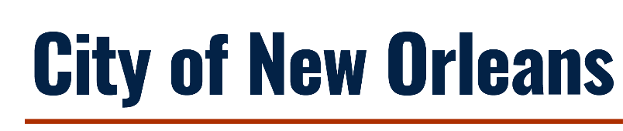

Notice of Funding Availability
Green Infrastructure Workforce Training & Development

Application Package

Office of Economic Development
1340 Poydras St., Suite 1800
New Orleans, Louisiana 70112
(504) 658-4904 | https://nola.gov/next/economic-development

NOTICE OF FUNDING AVAILABILITY (NOFA)

- OVERVIEW
Agency: Office of Economic Development (OED)
Contact: Ruda Pollard

Action: Notice of Funding Availability (NOFA) for Resilient Communities Infrastructure Program – Green Infrastructure Workforce and Business Development

Summary: The City of New Orleans seeks to utilize a portion of its Resilient Communities Infrastructure Program award to provide reimbursable grants to address the critical needs of the city’s non-profit partners to provide workforce development training applied to green infrastructure installations. The project will increase workforce capacity by training at a minimum of 75 Low to Moderate Income (LMI) individuals in green infrastructure (GI) construction and maintenance practices, with a goal of higher employment rates in sustainable and resilient industries. A total of $850,000 is available to be awarded to programs over the grant period.

Release Date: Application packets are available for download beginning June 25, 2026 from the City of New Orleans Office of Economic Development website https://nola.gov/next/economic-development/programs/green-infrastructure-workforce-and-business-development. Contact this office at (504) 658-4200 or Ruda Pollard at economicdevelopment@nola.gov to have the NOFA e-mailed to your organization.

Informational
Meeting: A virtual meeting will be held on July 9, 2026, at 1:00 PM CDT to answer general questions related to this NOFA and application. Call-in information will be circulated prior to the meeting. You may submit questions in advance of the meeting to Ruda Pollard at economicdevelopment@nola.gov.

Join the virtual informational meeting: TEAMS Meeting

Due Date: An electronic copy of a completed application must be submitted to the City of New Orleans via SUBJECT LINE email “RCIP-GI WORKFORCE” to Ruda Pollard at economicdevelopment@nola.gov by July 31, 2026, no later than 11:59 PM CDT.

Format: Use this packet as your grant application submission. When replying to prompts in each box, please use Calibri, 12-point font size to facilitate reading by scorers. Word limits for individual questions have not been established, but the applicant’s completed packet should not exceed 10 pages total, not including supporting documents. A complete application must include: the Application Packet (Appendix C).

Copies of any applications will not be made by the City of New Orleans. Proposals must be complete at the time of submission. No addenda will be accepted after the deadline date for submission of proposals. Under no circumstance should an applicant leave a proposal at or mail a proposal to the City of New Orleans.

APPLICATION PACKET
Please describe your proposed program by responding to the prompts below. Respond to all prompts in each section unless the question is identified as optional. When replying to prompts, please use Calibri, 12-point font to facilitate reading by scorers. This packet, including Sections 1 and 2, should not exceed 10 pages total, not including the supporting documents listed below.

Applications packets should be submitted via email to EconomicDevelopment@nola.gov along with the following supporting documents, as more fully described below:
  - Resumes of relevant staff
  - Line-item budget worksheet in Excel format
  - Most recent financial statements
  - Most recent Form 990
  - Recent audit, if applicable
Application Packet
Applicant Organization:
Applicant Address:
Form of Business: Nonprofit -
Program Summary: Provide a brief summary of the program or project:
Total Amount of Funding Requested:
Proposed Number of Participants Who are Residents of New Orleans (Orleans Parish) Reached:
Length of Proposed Program or Project:
Proposed Program or Project Start Date:
Proposed Program or Project End Date:

SECTION 1: GENERAL QUALIFICATIONS AND EXPERIENCE
- Provide a brief description of the objectives or mission statement of the organization or agency and relevant experience. How long has the organization been in existence?
- Describe the organization’s commitments to and expertise in workforce development in green infrastructure industries in New Orleans.
- Provide a brief description of Green Infrastructure programs successfully undertaken within the last 3 years.

SECTION 2: PROGRAM DESCRIPTION & CRITICAL NEEDS
- Provide a description of the critical needs of your organization to continue or expand existing programming. How have these needs been identified?
- Outline a timeline for use of the grant funds to address critical needs.
- Describe your organization’s current staff capacity or new staff positions that will be added to oversee the program functions or acquisition of materials related to critical needs as outlined in your narrative.
- Please include resumes of staff who will be integral to the program if they are existing staff in a separate attachment, if applicable.

SECTION 3: IMPACT
- How would a grant award from the City of New Orleans impact your existing programming? How would the number of participants, type of training, or other factors change if you are able to address your identified critical needs?
- How will you track program impacts? If desired impacts are not achieved at certain intervals, what changes will you make to the program?

SECTION 4: BUDGET NARRATIVE & BUDGET SPREADSHEET
Please provide a description of project costs below in a narrative format as part of this application packet. Please also include an Excel document that breaks down costs across allowable categories. An excel template is not being provided; create your own. All costs should be limited to the amounts that are necessary and reasonable to accomplish the program activities and must meet applicable federal eligibility restrictions. Any awarded project will be subject to the City’s feasibility and cost reasonableness analyses.

See the eligible and ineligible uses of funds in Section III. B. Scope of Work.
Restrictions on use of funds include, but are not limited to:
- Organizations must operate the funded program within the geographic boundary of the City of New Orleans.
- Program recipients reported on for the purposes of this grant must be City of New Orleans residents.

When submitting your proposal, include separate attachments with your Excel line-item budget and your organization’s financials, including your most recent 990 and a copy of your most recent financial statement. If you have an audited financial statement, please submit as a separate attachment.

Acknowledgements
The undersigned certifies and makes assurance of the Applicant’s compliance with:
- Organization does not owe Federal debt, any State of Louisiana debt, or any City of New Orleans debt.
- Applicant organization has met audit requirements to be considered for funding, including submission of organization’s most recent completed audit, and all audits of previously funded organizations are clear of ineligible/disallowed costs related to all funding provided by the City of New Orleans.
- No contractor principal, member, or officer has, within the preceding five years, been convicted of, or pled guilty to, a felony under state or federal statutes for embezzlement, theft of public funds, bribery, or falsification or destruction of public records.
- Proposals are in compliance with City funding commitments and do not have unresolved compliance issues.
- Title VI of the federal Civil Rights Act of 1964 https://www.hhs.gov/civil-rights/for-individuals/special-topics/needy-families/civil-rights-requirements/index.html;
- Title IX of the federal Education Amendments Act of 1972 https://www.justice.gov/crt/title-ix-education-amendments-1972
- The Equal Employment Opportunity Act and the regulations issued thereunder by the federal government https://www.eeoc.gov/statutes/laws-enforced-eeoc
- The Americans with Disabilities Act of 1990 and the regulations issued thereunder by the federal government http://www.ada.gov/pubs/ada.html;
- All contract employees performing services and/or work as a result of this solicitation must have documented legal authority to work in the United States of America;
- The condition that the submitted Application was independently arrived at, without collusion, under penalty of perjury; and
- The condition that no amount shall be paid directly or indirectly to an employee or official of the City of New Orleans as wages, compensation, or gifts in exchange for acting as an officer, agent, employee, subcontractor, or consultant to the Applicant in connection with the Procurement under this NOFA.

Yes No

_______________________________________________ _______________________
ORGANIZATION FED EMPLOYER ID NO.
_______________________________________________ ______________________
APPLICANT SIGNATURE DATE
_______________________________________________
PRINTED NAME
_______________________________________________
TITLE
PERSON RESPONSIBLE FOR PREPARATION OF APPLICATION
____________________________________  NAME | __________________________________  TITLE
________________________________________________________________________
ADDRESS
___________________________________ ____________ _______________________
CITY STATE ZIPCODE
____________________________________  PHONE NUMBER | __________________________________  EMAIL ADDRESS
PERSON RESPONSIBLE FOR PROGRAM AND CONTRACT MANAGEMENT
____________________________________  NAME | __________________________________  TITLE
________________________________________________________________________
ADDRESS
___________________________________ ____________ _______________________
CITY STATE ZIPCODE
____________________________________  PHONE NUMBER | __________________________________  EMAIL ADDRESS

APPENDIX F: CERTIFICATION REGARDING LOBBYING

44 C.F.R. PART 18 – CERTIFICATION REGARDING LOBBYING
Certification for Contracts, Grants, Loans, and Cooperative Agreements
The undersigned certifies, to the best of his or her knowledge and belief, that:

1. No Federal appropriated funds have been paid or will be paid, by or on behalf of the undersigned, to any person for influencing or attempting to influence an officer or employee of an agency, a Member of Congress, an officer or employee of Congress, or an employee of a Member of Congress in connection with the awarding of any Federal contract, the making of any Federal grant, the making of any Federal loan, the entering into of any cooperative agreement, and the extension, continuation, renewal, amendment, or modification of any Federal contract, grant, loan, or cooperative agreement.

2. If any funds other than Federal appropriated funds have been paid or will be paid to any person for influencing or attempting to influence an officer or employee of any agency, a Member of Congress, an officer or employee of Congress, or an employee of a Member of Congress in connection with this Federal contract, grant, loan, or cooperative agreement, the undersigned shall complete and submit Standard Form-LLL, “Disclosure Form to Report Lobbying,” in accordance with its instructions.

3. The undersigned shall require that the language of this certification be included in the award documents for all subawards at all tiers (including subcontracts, subgrants, and contracts under grants, loans, and cooperative agreements) and that all subrecipients shall certify and disclose accordingly. This certification is a material representation of fact upon which reliance was placed when this transaction was made or entered into. Submission of this certification is a prerequisite for making or entering into this transaction imposed by section 1352, title 31, U.S. Code. Any person who fails to file the required certification shall be subject to a civil penalty of not less than $10,000 and not more than $100,000 for each such failure.

The Contractor, _________________________________, certifies or affirms the truthfulness and accuracy of each statement of its certification and disclosure, if any. In addition, the Contractor understands and agrees that the provisions of 31 U.S.C. Chap. 38, Administrative Remedies for False Claims and Statements, apply to this certification and disclosure, if any.

_____________________________________
Signature and Title of Contractor’s Authorized Official Representative

____________________________________
Date

APPENDIX G: CONFLICT OF INTERST DISCLOSURE AFFIDAVIT

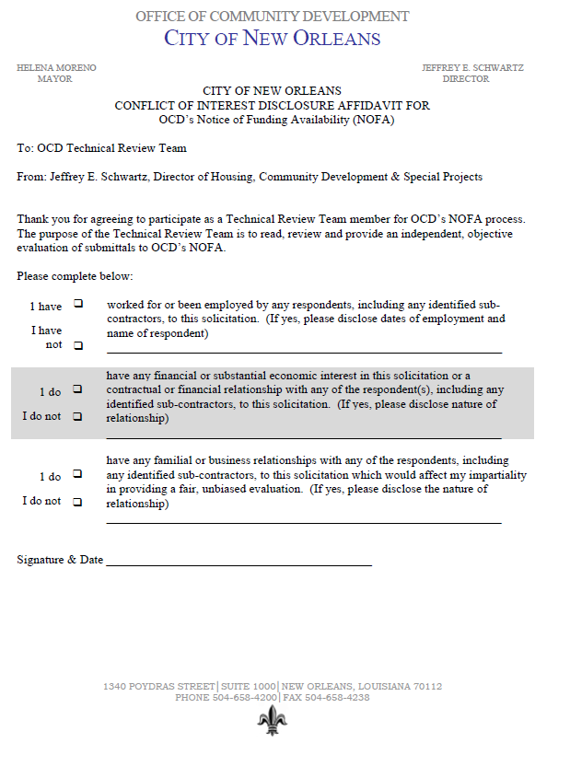

APPENDIX H: CONFIDENTIALITY DISCLOSURE

