NOCTURNL Communications Policy

All communications (including social media, press releases, etc.) should be saved and submitted within the Performance Reports.

* Press releases and events should also be submitted in real time, in addition to the reporting.

All communications are required to recognize the funding source (Inflation Reduction Act and US Forest Service).

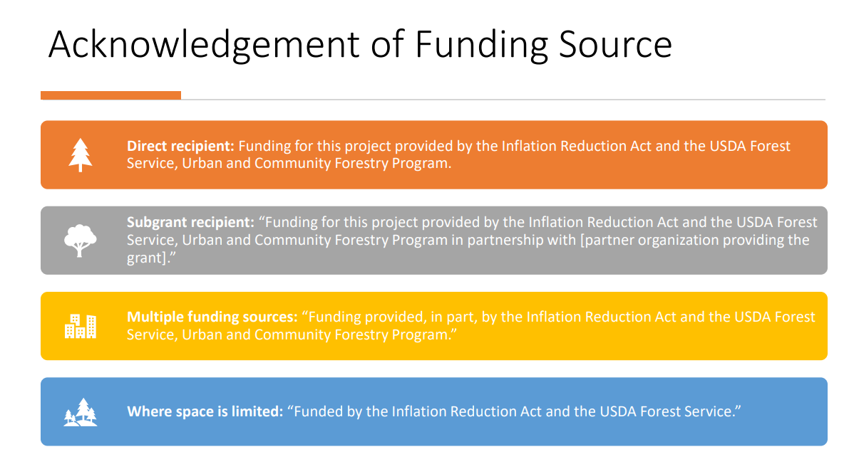

All visual materials require the nondiscrimination statement.

* Nondiscrimination Statement: “In accordance with Federal law and U.S. Department of Agriculture (USDA) civil rights regulations and policies, this institution is prohibited from discriminating on the basis of race, color, national origin, sex, age, disability, and reprisal or retaliation for prior civil rights activity. (Not all prohibited bases apply to all programs.)

Program information may be made available in languages other than English. Persons with disabilities who require alternative means of communication for Award Number: 24-DG-11083150-557 Page 8 of 23 program information (e.g., Braille, large print, audiotape, and American Sign Language) should contact the responsible State or local Agency that administers the program or USDA’s TARGET Center at (202) 720-2600 (voice and TTY) or contact USDA through the Federal Relay Service at (800) 877-8339.

To file a program discrimination complaint, a complainant should complete a Form AD-3027, USDA Program Discrimination Complaint Form, which can be obtained online at [https://www.ocio.usda.gov/document/ad-3027](https://www.usda.gov/directives), from any USDA office, by calling (866) 632-9992, or by writing a letter addressed to USDA.

The letter must contain the complainant’s name, address, telephone number, and a written description of the alleged discriminatory action in sufficient detail to inform the Assistant Secretary for Civil Rights (ASCR) about the nature and date of an alleged civil rights violation. The completed AD-3027 form or letter must be submitted to USDA by:

(1) Mail: U.S. Department of Agriculture, Office of the Assistant Secretary for Civil Rights, 1400 Independence Avenue SW, Washington, D.C. 20250-9410; or

(2) Fax: (833) 256-1665 or (202) 690-7442; or

(3) Email: [program.intake@usda.gov.](mailto:program.intake@usda.gov)”

* The short version is permissible if there is not room: "This institution is an equal opportunity provider.”

Use of the US Forest service logo is encouraged, however requires pre-approval ([Insignia Approval for Communication Products | US Forest Service](https://www.fs.usda.gov/managing-land/urban-forests/ucf/insignia-approval)). The City of New Orleans must submit a written request, and the Forest Service Program Manager will notify the City of New Orleans when permission is granted.

* Ask [Brittany.McGovern@nola.gov](mailto:Brittany.McGovern@nola.gov) for the Department of Parks & Parkways and Office of Resilience & Sustainability logos.