WARNING
TREE PROTECTION ZONE
NO WORK, EXCAVATION, STORAGE, OR DUMPING IS ALLOWED
FAILURE TO FOLLOW THE REQUIRED TREE PROTECTION MEASURES
MAY RESULT IN A STOP WORK ORDER AND CIVIL PENALTIES.
TO REPORT A SUSPECTED VIOLATION CALL (504) 658-3201
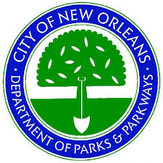
CODE OF THE CITY OF NEW ORLEANS SEC. 106-214

